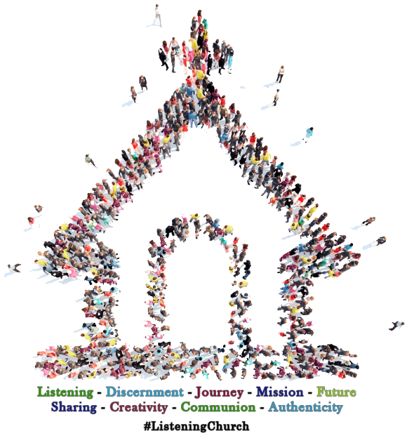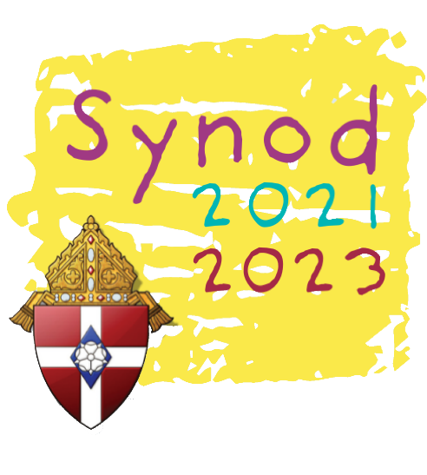

The Synod is a way for us to all journey together in order to discern and to listen to the voice of the Holy Spirit.   
Its goal is to promote communion, participation, and mission.

[Enter Text Here]

[Enter Text Here]

The entire people of God are invited to the synod!

**We look forward to seeing you there!**

***“It is precisely   
this path of synodality which God expects of   
the Church of   
the third millennium.”***

***-Pope Francis***

**HOW?**

**WHERE?**

**WHEN?**

**WHAT?**

**WHO?**

The primary way of participating in the Synod is in a spirit of listening – first   
to the Holy Spirit, then to each other.

Communion

Participation

Mission

SYNOD

2021 - 2023